Early Years Foundation Stage

Transition Pack for 2 - 4 year olds

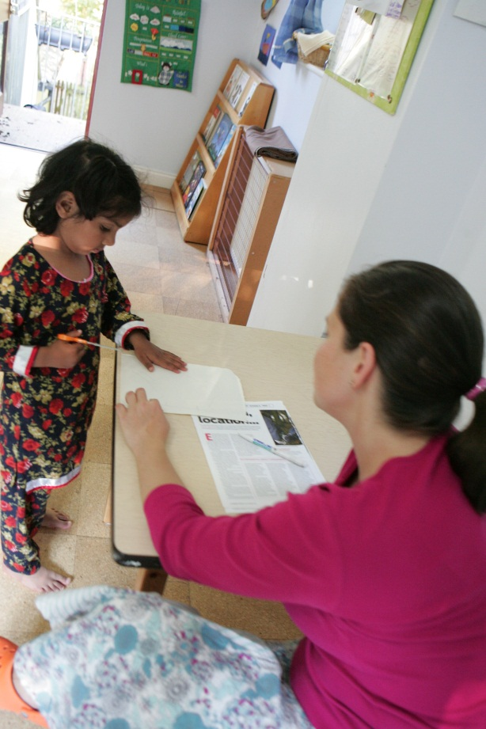 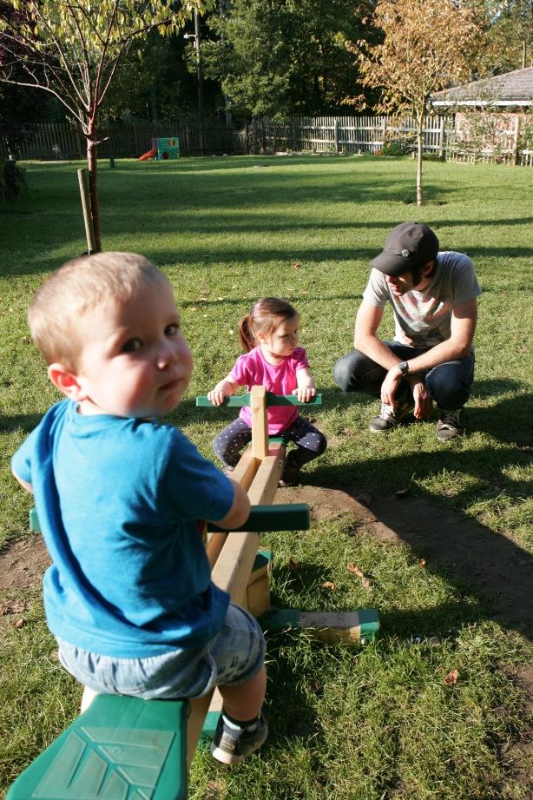 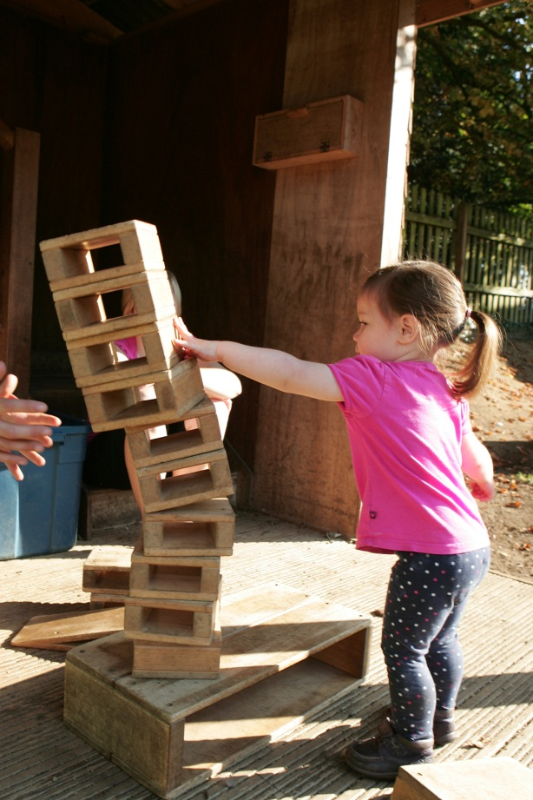

Produced by Oxfordshire’s Early Years Foundation Stage Advisory Team. Summer 2014

Early Years Foundation Stage Transition Pack for 2 – 4 years

Information sharing is an important part in helping parents, carers and practitioners to recognise children’s progress and understand their needs in a transition process. The effective sharing of information is part of high quality provision during the period of change between settings, and will help children and families.

The Nursery Education Funding Agreement sets out the requirements which need to be completed and complied with by all settings who receive funding for places.

Nursery Education Funding Agreement 2015 - 2016

Providers need to meet the requirements set out in the agreement for Partnership work by:

*4.1 Work in partnership with parents and provide them with any relevant information or advice about their child’s progress and grant entitlements.*

*4.2 Work collaboratively with other early years providers locally, particularly around splitting the entitlement, transition to school, and support local partnership activities, using Council approved transition documentation as published from time to time.*

*4.3 Subject to parents’ prior consent, transfer to the Council approved records of eligible children (as appropriate) for release to receiving schools and settings, including those records relating to achievements and identified Special Educational Needs.*

*(Extract from Nursery Education Funding Agreement 2015- 2016, p.8)*

This pack contains a set of documents to assist with transition and information sharing in the Early Years Foundation Stage, when children are moving from Preschool/Nursery to Reception or another setting. **It is a Local Authority requirement that funded settings must complete a transition report for each child who moves setting, but the format can be decided by your setting. The following formats include the necessary contents.**

Documents found in the pack:

1. Early Years Foundation Stage – Learning and Development Summary at 24-36 months (document 1 page 5)
2. Communication Passport (document 2 page 7)
3. Early Years Foundation Stage – Summary of Key information on Transition (document 3 page 8)
4. Early Years Foundation Stage - Learning and Development Transition Summary (document 4 page 9)

* **Early Years Foundation Stage Progress check at two years old**

The EYFS Progress check **MUST** be completed for children between the ages of 30-36 months by the practitioner who know the child well (Key Person). This needs to be a holistic picture of the child, so should be based on parent/carer contributions to children’s development, alongside practitioner contributions. If a child moves settings between the ages of two and three it is expected that the progress check would usually be undertaken by the setting where the child has spent the most time.

**Early Years Foundation Stage – Learning and Development Summary at 24 – 36 months**

(Document 1 page 5)

The information contained within this report needs to be completed by the child-minder/setting for a child. This will show the EYFS Progress for the check at two years old and needs to be completed before the child transfers to a new setting.

* **Communication Passport** ( document 2 page 7)

This provides an opportunity for practitioners and parents/carers to give details of an individual child’s likes and dislikes. This can be completed, when a child transfers, to support a smooth transition for the child.

* **Early Years Foundation Stage – Summary of Key information on Transition** (document 3 page 8)

This provides key information for practitioners. This can follow a child throughout the EYFS and can be updated regularly.

* **Early Years Foundation Stage - Learning and Development Transition Summary** (document 4 page 9)

This document gives an overview of a child’s achievement in the Prime and Specific Areas of Learning and Development and the Characteristics of Effective Learning. This is for parents/carers and the next setting.

This pack should be used in conjunction with the following documents:

* [Nursery Education Funding agreement](http://www.oxfordshire.gov.uk/cms/sites/default/files/folders/documents/childreneducationandfamilies/workingwithchildren/publicationssettings/nurseryeducationfundingagreement.pdf) (NEF) (Oxfordshire County Council 2015-2016)
* [Statutory Guidance for Local Authorities](https://www.education.gov.uk/aboutdfe/statutory/g00209650/code-of-practice-for-las)
* [A Know How Guide – The EYFS Progress Check at age two](http://www.foundationyears.org.uk/eyfs-statutory-framework/) (DfE March 2012)
* [Development Matters in the EYFS](http://www.foundationyears.org.uk/wp-content/uploads/2012/03/Development-Matters-FINAL-PRINT-AMENDED.pdf) (DfE March 2012)
* [Statutory Framework for the EYFS](https://www.gov.uk/government/publications/early-years-foundation-stage-framework--2) ( DfE September 2014)
* Early Years [Developmental Journal](http://www.ncb.org.uk/media/894183/early_years_developmental_journal2013.pdf) ( Early Support DfE January 2013)
* The [SEND code of practice: 0 to 25](https://www.gov.uk/government/publications/send-code-of-practice-0-to-25) (DfE 2015)
* [Oxfordshire's SEN handbook for Early Years Settings and Services.](https://www.oxfordshire.gov.uk/cms/sites/default/files/folders/documents/childreneducationandfamilies/educationandlearning/specialeducationalneeds/SEND/CompilationFoundationYearsandPrimary.pdf)

|  |  |  |  |
| --- | --- | --- | --- |
| Document 1 | | | |
| Early Years Foundation Stage - Learning and Development Summary at 24-36 Months | | | |
| Setting: | | | |
| Name: | Date of Birth: | Age in Months: | Key Person: |

|  |  |  |  |  |  |
| --- | --- | --- | --- | --- | --- |
| Personal, Social and Emotional Development | | Physical Development | | Communication and Language | |
|  | |  | |  | |
| Self-confidence and self-awareness e.g. 22-36 B Months | Months | Moving and handling | Months | Listening and attention | Months |
| Making relationships | Months | Health and self-care | Months | Understanding | Months |
| Managing feelings and behaviour | Months |  |  | Speaking | Months |
| Next Steps to support learning and development | | Next Steps to support learning and development | | Next Steps to support learning and development | |
| Comments relating to the 3 Characteristics of Effective Learning: (See ‘Development Matters in the EYFS’) | | | | | |
| Playing and Exploring  Finding out and exploring; Playing with what they know; Being willing to have a go | | | | | |
| Active Learning  Being involved and concentrating; Enjoying and achieving what they set out to do; Keeping on trying | | | | | |
| Creating and thinking critically  Having their own ideas; Making links; Choosing ways to do things | | | | | |
| Parents/Carers comments | | | | | |
| Other professionals involved | | | | | |
| Key Person Signature ……………………………………………………..  Parent/Carer Signature ……………………………………………………  Date completed ……………………………………………………………. | | | | | |

Document 2

Communication Passport

|  |  |  |
| --- | --- | --- |
| Things I like: | Things it will help you to know about me: | Things I don’t like: |
| When I am happy I …. | Communication Passport  Name:  D.O.B:  Setting: | When I am sad I ….. |
| When I am anxious I …. | When I am distressed these things help me …. | When I am angry I …. |
| Moving around and staying safe: | These people help me (e.g. Physio, Speech & Language Therapist): | My self-help skills: |

Document 3

Early Years Foundation Stage – Summary of Key Information on Transition

|  |  |  |  |  |
| --- | --- | --- | --- | --- |
| Name of Setting | | Name of Child | Date of Birth | |
| Date started at setting | | Other settings attended | Pattern of attendance/number of sessions  Mon, Tue, Wed, Thurs, Fri | |
| Home Language  SEN statement and/or most recent review. | | Name of child’s new setting or school | Additional information  Looked after child Yes/No  Personal education plan included Yes/No  Common Assessment Framework Yes/No  Child Protection Plan Yes/No | |
| Photo of child | SEND Code of Practice: What stage? Circle one of the following  SEN support Education Health & Care Plan or Statement of SEN  Type of intervention: e.g. Speech & Language, Behaviour Plan  Impact?  Last review date:  Please attach, and list below, any relevant documentation e.g. SEND statement/ child plan or most recent review, Communication Passport, Learning & Development, Transition Summary | | | General information relating to dietary needs, health, allergies. |
| Other professionals involved | | |
| Key Person …………………………………………………Signed ………………………………………………… Date……………….. | | | | |

|  |  |  |  |
| --- | --- | --- | --- |
| Document 4 | | | |
| Early Years Foundation Stage – Learning and Development Transition Summary | | | |
| Setting: | | | |
| Name: | Date of Birth: | Age in Months: | Key Person: |

|  |  |  |  |  |  |
| --- | --- | --- | --- | --- | --- |
| Personal, Social and Emotional Development | | Physical Development | | Communication and Language | |
|  | |  | |  | |
| Self-confidence and self-awareness e.g. 30–50 B Months | | Moving and Handling Months | | Listening and attention Months | |
| Making relationships Months | | Health & self-care Months | | Understanding Months | |
| Managing feelings and behaviour Months | |  | | Speaking Months | |
| Next Steps to support learning and development | | Next Steps to support learning and development | | Next Steps to support learning and development | |
| Literacy | Mathematics | | Understanding the World | | Expressive Arts & Design |
|  |  | |  | |  |
| Reading Months | Numbers Months | | People and communities Months | | Exploring and using media and materials  Months |
| Writing Months | Shape, space and Months  measures | | The world Months | | Being imaginative Months |
| Technology Months | |
| Next Steps to support learning and development | Next Steps to support learning and development | | Next Steps to support learning and development | | Next Steps to support learning and development |
| Comments relating to the 3 Characteristics of Effective Learning: (See ‘Development Matters in the EYFS’) | | | | | |
| Playing and Exploring  Finding out and exploring; Playing with what they know; Being willing to have a go | | | | | |
| Active Learning  Being involved and concentrating; Enjoying and achieving what they set out to do; Keeping on trying | | | | | |
| Creating and thinking critically  Having their own ideas; Making links; Choosing ways to do things | | | | | |
| Parents/Carers comments | | | | | |
| Other professionals involved | | | | | |
| Key Person Signature ……………………………………………………..  Parent/Carer Signature …………………………………………………… Date completed ………………………………………………. | | | | | |

Early Years Developmental Journal

The Early Years Developmental Journal is designed for families, practitioners and others to use as a way of recording, celebrating and supporting children's progress. It is also for people who would like to find out more about children's development in the early years. It supports key working by helping everyone involved with a child to share what they know and discuss how best to work together to support development and learning. This Journal is particularly useful if you know or suspect that your child or a child who you are helping is unlikely to progress in the same way or at the same rate as other children - whether or not a particular factor or learning difficulty has been identified and given a name.

Download a full copy of the report here:

<http://www.ncb.org.uk/media/894183/early_years_developmental_journal2013.pdf>

There is also a practice guidance that goes alongside this journal which is particularly helpful for practitioners

<http://www.councilfordisabledchildren.org.uk/media/537317/eydj_practice_guidev2.pdf>

Families of some disabled children/children with SEND may also be using other Early Support resources alongside or integrated in their IEP. These additional materials celebrate progress, support shared planning, and include other Early Support Developmental Journals for children with specific identified needs. Some may also use a Family File and Service Plan to identify next steps and priorities for both the family and the child. The transition document should clearly take account of, and value all the information provided and should be developed with the parents/carers to ensure it is relevant and appropriate for them.

All Early Support Materials are available from: [www.councilfordisabledchildren.org.uk/earlysupport](http://www.councilfordisabledchildren.org.uk/earlysupport)