**BIKEABILITY REGISTRATION/PARENTAL CONSENT FORM**

Bikeability information: <https://bikeability.org.uk/what/>

|  |  |
| --- | --- |
| COURSE VENUE |  |
| DATES |  |

COURSE INSTRUCTIONS: Participants need to have experience of riding a bike with good control, a road worthy bike of a suitable size and a well-fitting cycle helmet(standard EN1078) that is in good condition. Both will be checked at first session.

Please wear appropriate clothing/footwear, and bring waterproofs/coat; water; inhalers if needed.

Trainees will be using the public highway for their training. Roads with an appropriate traffic flow will be chosen and risk assessed on a daily basis.

Trainees are expected to use appropriate behaviour and follow the instructions of the instructor at all times. Inappropriate behaviour will result in the child being removed from the course.

|  |  |  |  |  |
| --- | --- | --- | --- | --- |
| NAME |  | | | Preferred name if different |
| Age |  | | Parental consent to participate in course  Print name: | |
| Consent for photograghs | Yes | No |

|  |  |
| --- | --- |
| Emergency contact name |  |
| Emergency contact number |  |

|  |
| --- |
| HEALTH AND BEHAVIOURAL INFORMATION  Please provide any information relevant to this cycle training course. |
|  |

**Bicycle check list** – Before your child attends the Cycling Training Course, please would you ensure the following items have been checked. If you are unsure about what to do please seek the assistance of your local cycle shop.

**Cycle Helmet** – please ensure it is correctly adjusted so that there is no great movement either up or down. A good test is to put your hand flat on your nose & push your hand up towards your helmet. If the helmet moves easily away from your forehead then it is too loose & needs readjusting.

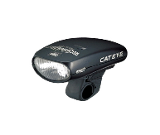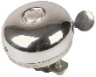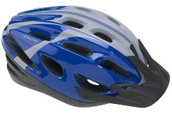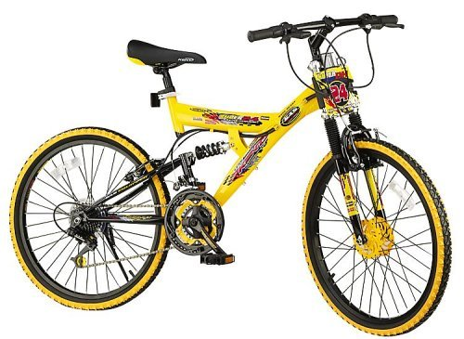

**Saddle Height** – Cyclist should be able to touch the ground with the balls of both feet whilst sitting on the saddle. If the feet are flat on the ground the saddle is too low. Check saddle does not move up/down or left/right.

**Front/Rear Brakes** – Please ensure that they are in full working order. The brakes blocks should grip the rim when the brake is applied & not touch the rim when released.

**Tyres** – Please ensure that they have a good tread & are pumped up hard. Any punctures must be fixed.

**Wheels** - Check wheels are not bent or buckled. Check the wheel nuts are tight.

**Spokes** – Check they are tight, replace any missing ones.

**Headset –** Check for “Shake” by lifting bike off the ground. If the frame moves or rattles before the front wheel then the headset needs tightening

**Handlebars** – Check the handlebars are tight by standing astride the front wheel & trying to turn the handlebars.

**Chain** – The chain should be well oiled. Check the tension so that it will not come off in use.

**Gears** – Where gears are fitted please ensure they are correctly adjusted so that the chain does not come off when changing gear.

**Back Reflector** – This is required between sunset & sunrise, & kept clean

**Pedals –** They spin freely, the shaft connecting both pedals through frame is tight

**Bell** – This is not required although it is a good idea to have one fitted.

**Front/Rear Lights** – These are required between sunset & sunrise & in poor visibility.